CS6314.002-Team5-RV Rentals
Hao Si (hxs180013),Feng Mi(fxm150930)

Project Title: RV Rental

Website Name: Just RV Rental

Project Description:

Just RV Rental is a web based rv rental company and it mainly focuses on the rv rental on the Internet. Users can easily see the details about the Rvs that are currently available and set up online orders. If the Rvs user wants to rent it is currently available, they can choose to add to the wish list.User can also know what they brought before by seeing their history. For the admin, he can easily maintain the inventory by adding the new RVs or delete the currently RVs.

Database design:
We choose to use MongoDB. Here is the information about our Mongodb data model:

4 Collections:

Rvs which record basically the details of each RV.

Accounts which record the auth info about the users. For the password, we just record the hash value of the passowrd. We do not store the raw input of the user password to better protect the user privacy.

Carts which record the item which users save for buying in the future.

Purchase history records the every purchase for every user.

Languages/frameworks:
HTML,css,Javascript,jquery,node.js,json,Express

Screenshots for the Main function:

List products and search,filter,paging function:
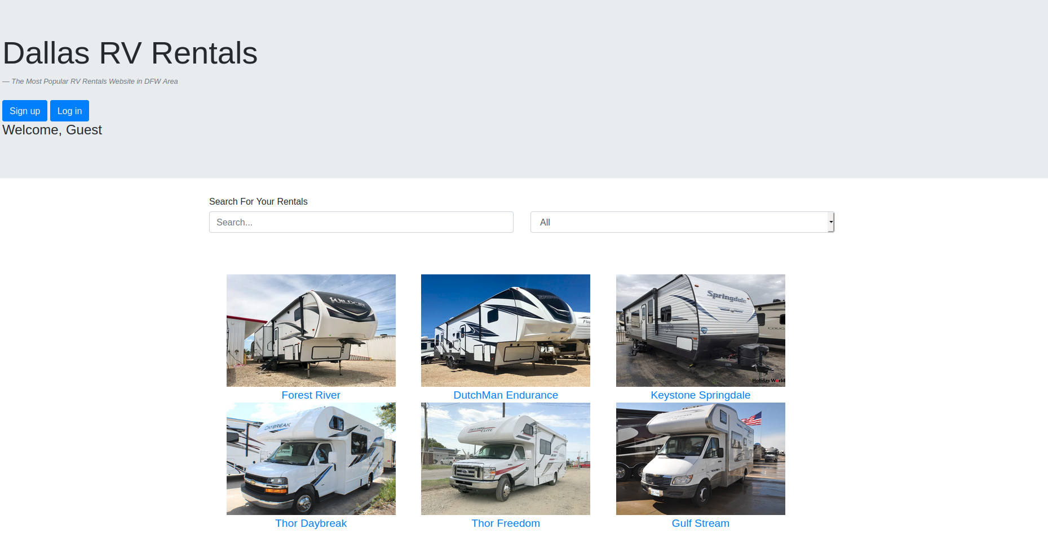
Shopping cart and its edit feature:
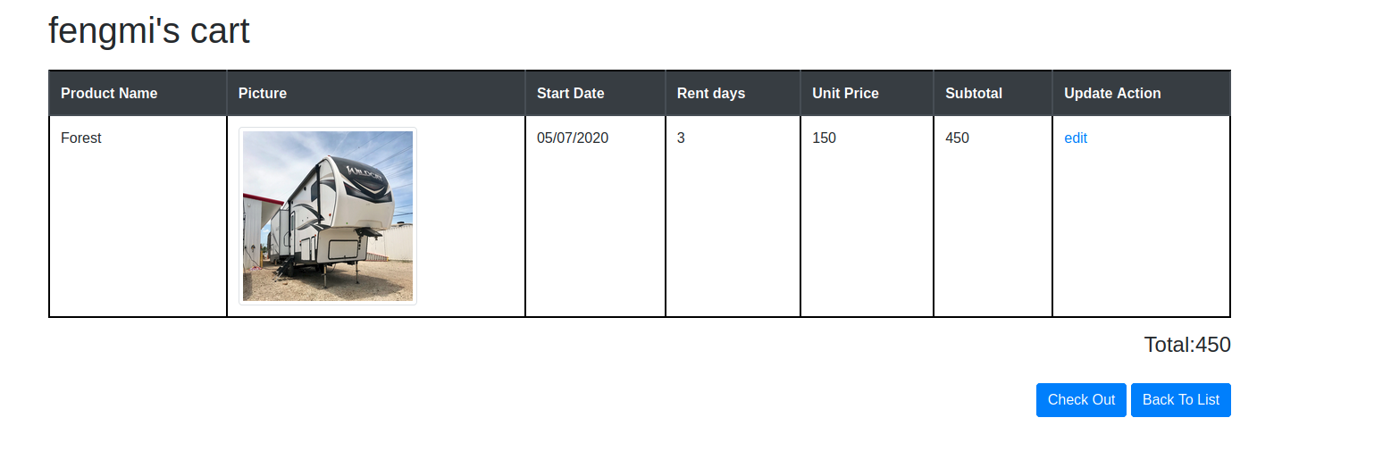

Rv Detail:
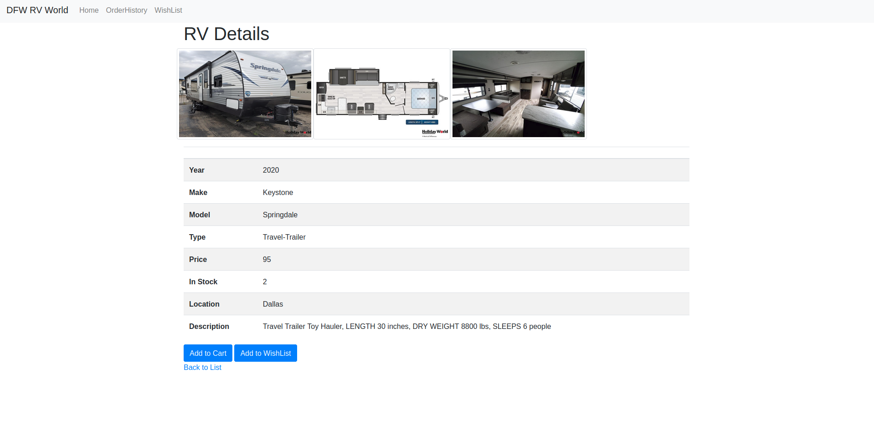
Admin Function:
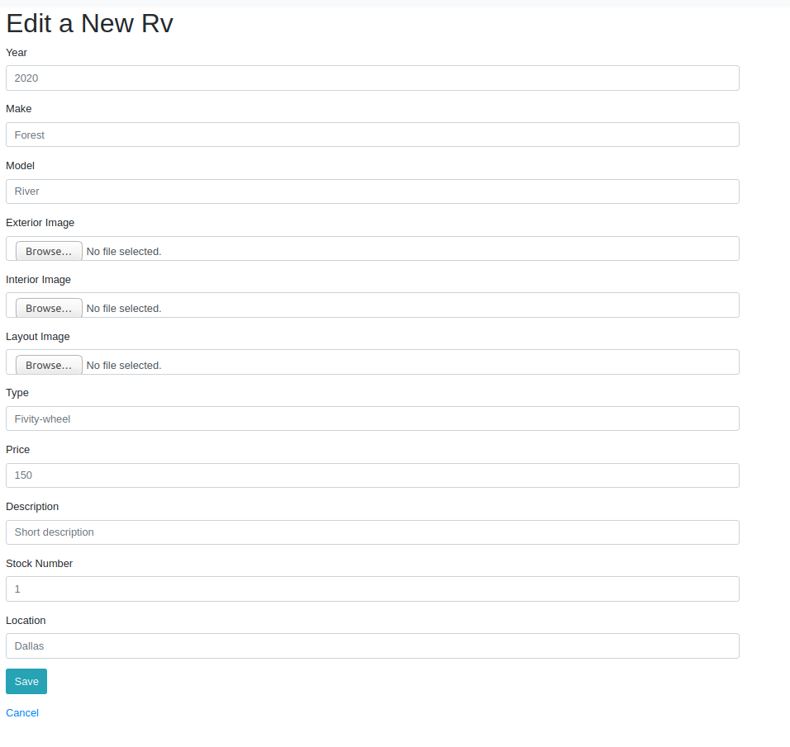

User sign up and its validation method:

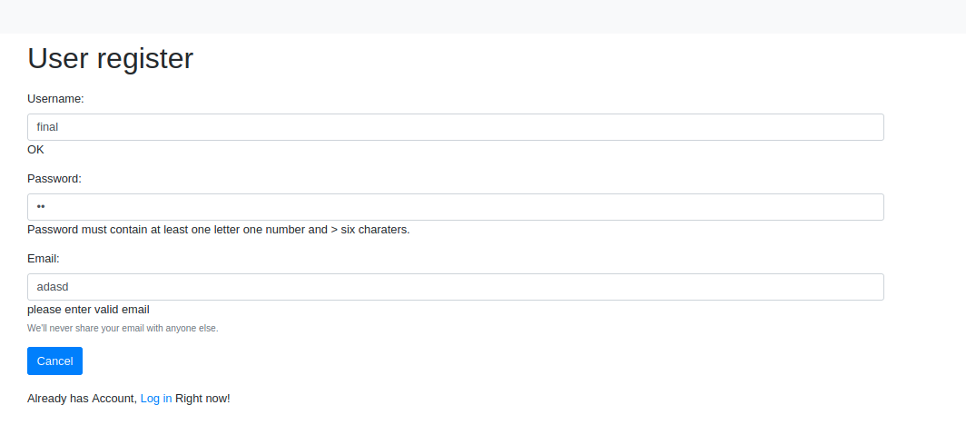

Team members:
Feng Mi fxm150930
Hao Si hxs180013

Work division:

Hao Si:
- List products / paging (if isAdmin , list another button)
- History of purchases or saved lists
- Admin User /
- Soft delete feature
- Design mongodb data model and create some data
- Maintain the gitlab repo

Feng Mi:
- Implement the function for user sign up , user login
- Cart / Checkout / Update feature
- Design the mongodb data model and create some data
10.Maintain the gitlab repo

